1. Outline each of the Problem Solving Steps for your Snap problem and write a line or two under each heading
   * Penuel wrote a function that ask a user to type either rocks/paper or scissor and then a variable where they can type their choices. But Lawrence came up with an alternative; he suggested that it is better to assign them to numbers instead of letting the user type the whole string.
   * So I took Lawrence suggestion and implemented it in my program.
   * Lawrence also did search for an image for our character.
2. Progress to date – Provide an overview

* By Monday 5th Dec 2016, we would have finish the basic functions for rocks, paper and scissors. And then improvise or add character such as image.

1. Screenshots of who is done what on the project

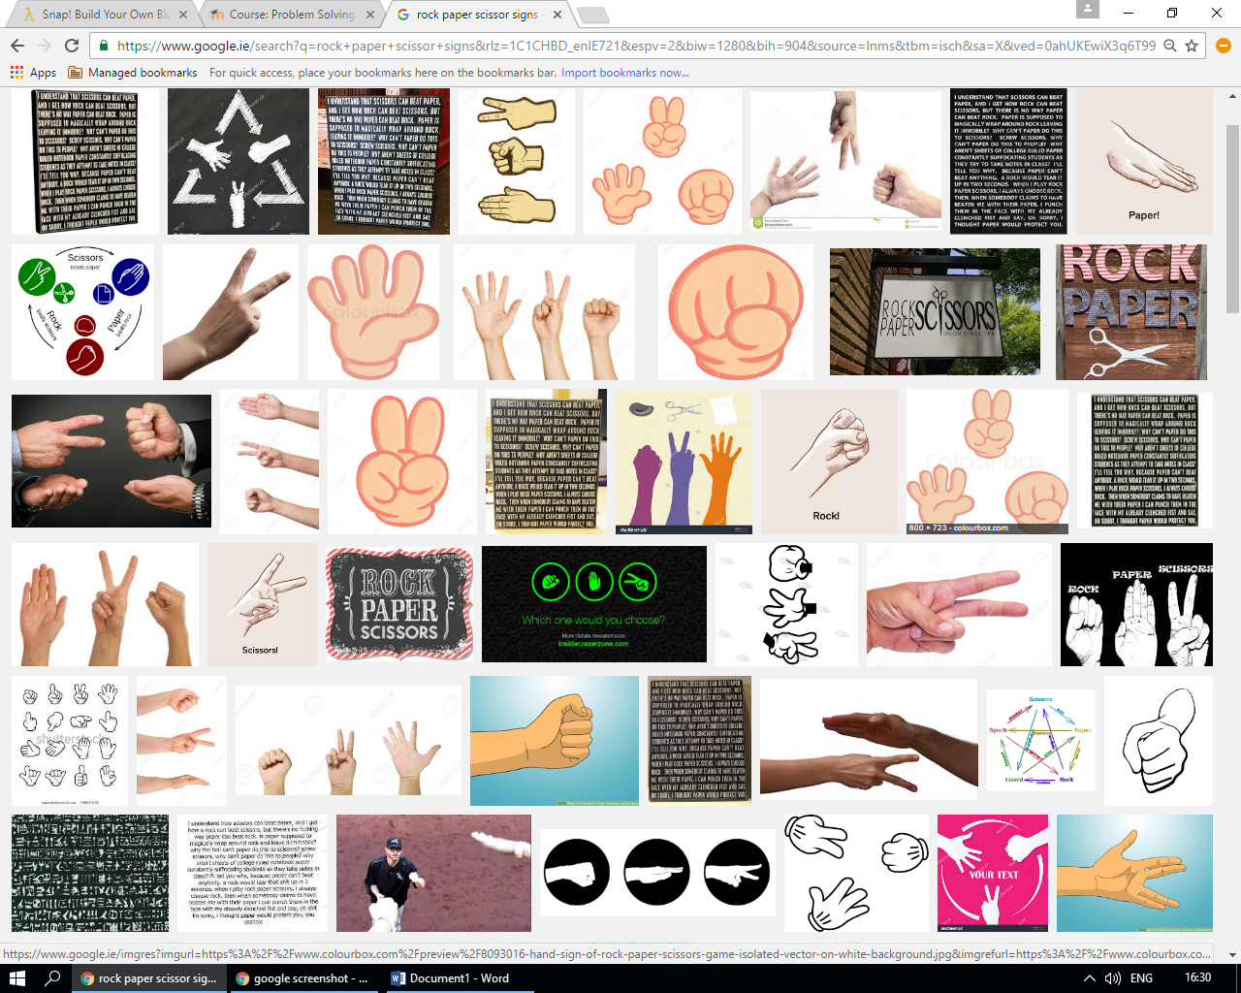

* + Above is a screenshot of Lawrence searching for costumes/characters
  + 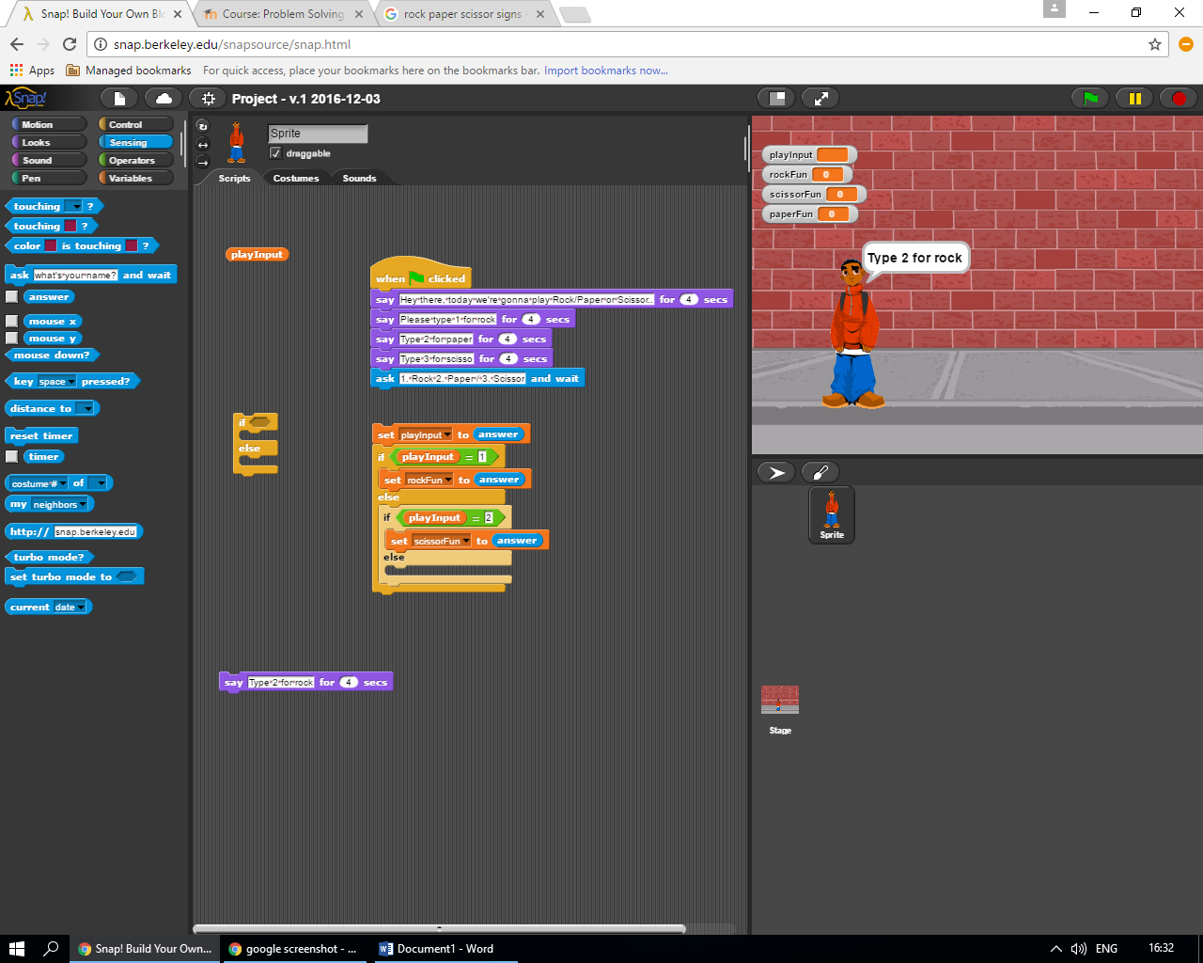
  + Above is Penuel’s Snap in progress….

1. Outline what is left to do

* Charts
* How it will change the sprites for a certain outcomes.